## Section: 16-2: The Sixteenth Vassa & Seventeenth Vassa (Age 50 & 51)

This section describes how the Buddha spent his sixteenth and seventeenth rainy seasons and significant events happened during those times.

## The Sixteenth Vassa

In the previous section (16-1), we explored how the Blessed One spent his fifteenth rainy season in Nigrodhārāma, Kapilavattu, his hometown. Following the completion of the vassa, the Buddha set out from Kapilavattu, eventually arriving in Sāvatthi, where he resided at Jetavana Monastery. There, he delivered numerous profound Dhamma teachings, benefiting both the Sangha and the lay community. However, as the next rainy season approached, the Buddha, instead of remaining in the familiar setting of Sāvatthi, embarked on a significant journey—alone.

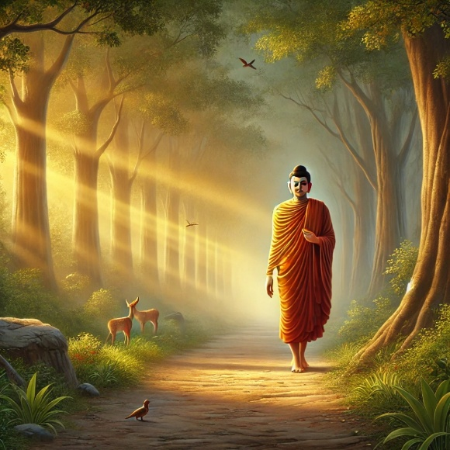

**The Buddh’s solitary walk to Āḷavī [1]**

## The Buddha’s Solitary Walk to Āḷavī

Tradition holds that the Blessed One, unaccompanied by the monastic community, walked a great distance—thirty yojanas (approximately 380 km)—from Sāvatthi to Āḷavī, a journey marked by his profound renunciation, fearlessness, and compassion. [2]

The Buddha often undertook such solitary travels, demonstrating the ideal of self-reliance and deep meditation, while also reaching people in remote regions who had never before encountered the Dhamma. This journey to Āḷavī was no exception, and his presence there would have a lasting impact on the region. Though the sutta does not explicitly confirm that the Buddha spent the sixteenth vassa in Āḷavī, various sources indicate that he frequently visited and taught there.

# The Buddha’s Sixteenth Rainy Season in Āḷavī

Multiple sources confirm that the Blessed One spent his sixteenth vassa in the ancient city of Āḷavī, a region steeped in history and spiritual significance.

1) Having tamed (the yakkha) Āḷavaka and making 84,000 creatures imbibe the immortal ambrosia, (he spent) the sixteenth at Āḷavī *( soḷasamaṁ Āḷavakaṁ dametvā caturāsītipāṇasahassāni amatapānaṁ pāyetvā Āḷaviyaṁ) [3]*

2) After guiding the very harsh *yakkha* (Ālavaka) to a state of good discipline, while leading a great many people along the Path to Peace, in the sixteenth Rains Retreat, he dwelt near the very excellent city named Ālavaka. *(Kakkhala-taraṁ yakkhaṁ pi su-vinīta-bhāvaṁ netvā, bahu-taraṁ pi janaṁ ca santi-maggaṁ netto, dasachaṭṭhamamhi Vassamhi, varatam-Ālavaka-abhidhāne pure vāsam-akarī.)[4]*

3) On the day of the sacrifice of the baby prince Ālavi, [5]the Buddha rose in the early morning and engaged in mahā-karunā-samāpatti in his chamber inside the Jetavana monastery…he saw in vision three significant things: **i** the past merits of prince Ālavi **ii** the past merits of Yakka Ālavaka **iii** the past merits of eighty-four thousand beings who would realize the Dhamma. Accordingly, at day break he performed his morning duty …on the sunset of the new-moon day set out on foot alone on a journey of thirty yojanas from Sāvatthi and entered the precinct of yakka Ālavaka’s residence.[6]

### Buddha’s Presence in **Āḷavī**

The Buddha’s presence in Āḷavī is mentioned in several suttas within the Sutta Piṭaka, suggesting that he spent significant time in the city and surrounding areas.

## Strategic Location of Āḷavī

* A town thirty leagues from Sāvatthi and probably twelve from Bārāṇasī. It lay between Sāvatthi and Rājagaha. (The Buddha goes from Sāvatthi to Kiṭāgiri, thence to Āḷavī, and finally, to Rājagaha). The Buddha, on several occasions, stayed at Āḷavī at the [Aggāḷava Cetiya](https://www.aimwell.org/DPPN/aggalava-cetiya.html) which was near the town. [7]

## The Importance of Āḷavī in Buddhist History

* The Blessed One preached the Dhamma to 84,000 beings, marking Āḷavī as a significant place of conversion and refuge. According to tradition after the taming of Yakka Āḷavakaka, the King of Āḷavī and the people of the country became the followers of the Buddha. [8]
* The city was home to Prince Hatthaka Āḷavaka, a prominent lay disciple known for his deep faith and generosity. The Buddha declared him as the foremost among those who make use of the four means of attracting and sustaining others [9]
* Therī Selā, a renowned female arahant, was born in Āḷavī and was therefore known as Āḷavikā [10]
* A large monastic community flourished in Āḷavī, with many monks dedicating themselves to building vihāras and spreading the Buddha’s teachings.[11]

## Modern Identifications: Āḷavī and Ghazipur

* Āḷavī has been identified by scholars such as Cunningham and Hoernle with Newal or Nawal in the Urao district in the United Provinces, and by Nandalal Dey, with Aviwa, twenty-seven miles north-east of Etwah.[12]
* Ālavī was a small state located near the [Gaṅgā](https://en.wikipedia.org/wiki/Ganges" \o "Ganges) river. [Alexander Cunningham](https://en.wikipedia.org/wiki/Alexander_Cunningham) and [Vincent Arthur Smith](https://en.wikipedia.org/wiki/Vincent_Arthur_Smith) identified Ālavī with the [Ġāzīpur](https://en.wikipedia.org/wiki/Ghazipur_district" \o "Ghazipur district) region. **Ghazipur**, is a city in the state of [Uttar Pradesh](https://en.wikipedia.org/wiki/Uttar_Pradesh), India. Ghazipur city is the administrative headquarters of the [Ghazipur district](https://en.wikipedia.org/wiki/Ghazipur_district), one of the four districts that form the [Varanasi division](https://en.wikipedia.org/wiki/Varanasi_division) of Uttar Pradesh. It is located on the Ganges (Ganga) River near the border with Bihar state, about 40 miles (65 km) northeast of Varanasi [13]
* Ghazipur lies near the Uttar Pradesh-Bihar border, about 80 km east of Varanasi, making it a plausible location for ancient Āḷavī.

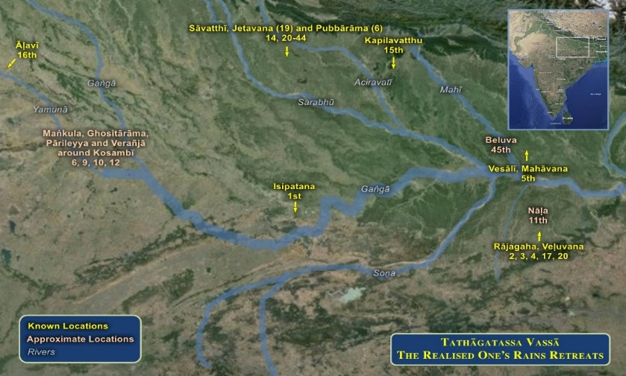

**Map showing the location of Ālavī during the time of the Buddha [14]**

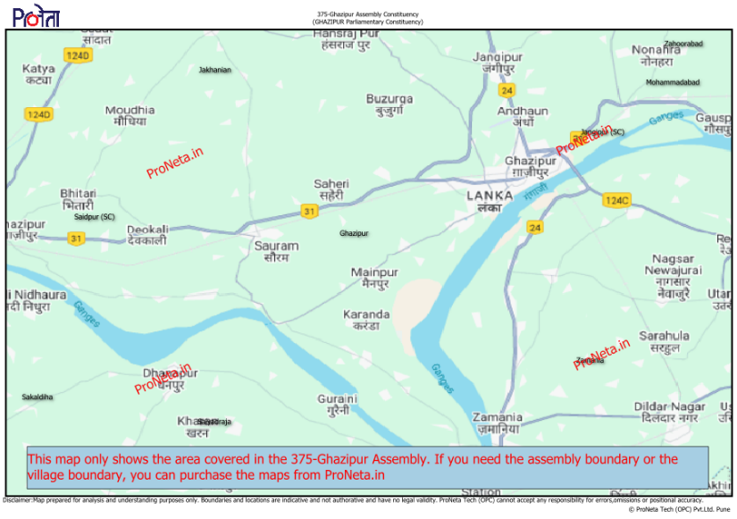

**Modern day map showing the location of Ghazipur in UP, India along the River Ganges [15]**

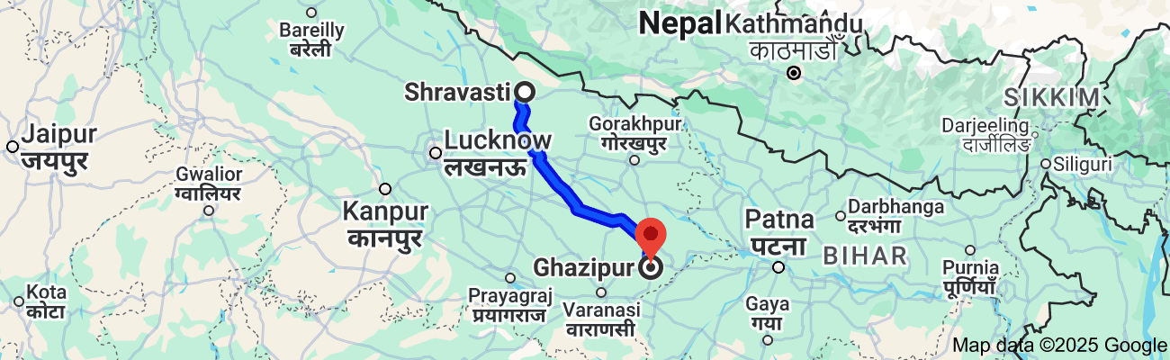

**Road map: Distance from Shravasti to Ghazipur (formerly Ãlavi) 322.5km[16]**

## The Yakkha Āḷavaka and the Buddha’s Fearless Encounter

In the sacred verses of the Yakkha Saṁyutta, [17] a remarkable encounter unfolds—one that reveals the Buddha’s boundless wisdom and unshakable fearlessness. During his stay in Āḷavī, the Blessed One took residence at the domain of Āḷavaka, a powerful and terrifying Yakkha known for his wrathful nature and dominion over the region. As we have described in Section 7, the Buddha, with his profound patience and unmatched skill in teaching, subdued the fierce Yakkha not through force, but through wisdom and compassion.

Determined to assert his dominance, Āḷavaka sought to intimidate the Buddha, declaring:  
*"I will ask you a question—if you do not answer, I shall split your heart asunder, or seize you and hurl you across the Ganges!"[18]*

Yet, the Blessed One, embodying both supreme confidence and universal compassion, replied with serene majesty:  
*"I see no one in this world who could split my heart or seize me and hurl me across the Ganges. But ask whatever you wish, friend."*

### A Profound Dialogue on the Highest Truth

Humbled but still curious, Āḷavaka asked:

“What is a man’s greatest treasure?  
What, when practiced well, brings happiness?  
What is the sweetest of all tastes?  
Who is the one that is said to live best?”

The Buddha, the Teacher of Gods and Humans, responded with deep wisdom:

“**Faith** is a man’s greatest treasure.  
**Dhamma**, practiced well, brings true happiness.  
**Truth** is the sweetest of all tastes.  
**One who lives by wisdom** is said to live best.”

### The Deeper Meaning

Faith is considered the greatest treasure because it leads to both mundane and supramundane happiness. It alleviates the burdens of birth and aging, dispels the poverty of noble qualities, and paves the way for the attainment of the sublime gems of enlightenment. The practice of Dhamma—through **generosity, virtue, and meditation**—bestows happiness in this life and beyond, culminating in the supreme peace of Nibbāna. Truth surpasses all tastes, for while material sustenance nourishes the body, the taste of truth nourishes the mind with serenity and insight, offering an undefiled happiness that transcends worldly pleasures.

Indeed, the one who dwells in wisdom—seeing reality as it truly is, free from delusion—lives the highest life, the life of true liberation! [19]

### The Path to Crossing the Flood and Attaining Wisdom

Humbled yet eager to learn, Yakkha Āḷavaka sought deeper truths and asked the Blessed One:

“How does one cross over the flood?  
How does one traverse the stormy sea?  
How does one overcome suffering?  
How is one purified?”

The Buddha, with perfect clarity, replied:

“By **faith,** one crosses over the flood.  
By **diligence**, one conquers the stormy sea.  
By **energy,** one overcomes suffering.  
By **wisdom**, one is purified.”

### The Deeper Meaning

The "flood" symbolizes the vast and treacherous ocean of **saṃsāra**, the cycle of birth and death, which is fourfold:

* **The flood of sensual desire (kāmāsava)**
* **The flood of craving for existence (bhavāsava)**
* **The flood of wrong views (diṭṭhāsava)**
* **The flood of ignorance (avijjāsava)**

It is through **faith**—the foundation of the path—that one takes the first step toward liberation, as a stream-enterer (sotāpanna), who has crossed the dangerous currents of false views.

Through **diligence**, one becomes a once-returner (sakadāgāmī), reducing attachment and gradually overcoming the craving for existence. With **energy**, one becomes a non-returner (anāgāmī), fully conquering the flood of sensuality, leaving behind the vast mass of suffering.[20]

### The Way to Wisdom and Lasting Happiness

Still seeking deeper understanding, Yakkha Āḷavaka asked further:

“How does one gain wisdom?  
How does one find wealth?  
How does one achieve acclaim?  
How does one bind friends to oneself?  
When passing from this world to the next,

how does one remain free from sorrow?”

With boundless compassion, the Blessed One revealed:

“Placing faith in the Dhamma of the Arahants,  
Through the desire to learn, one gains wisdom.  
By diligence and discernment, wisdom grows.”

### The Deeper Meaning

The Buddha here outlines the fourfold path to wisdom:

1. **Faith (Saddhā):** One must first place unwavering faith in the Dhamma—the noble path by which the Buddhas, Paccekabuddhas, and their enlightened disciples attained Nibbāna. Faith alone is not enough, but it serves as the gateway to wisdom.
2. **Desire to Learn (Sussūsā):** Inspired by faith, one approaches a teacher, listens intently, and absorbs the Dhamma with sincerity.
3. **Diligence (Appamāda):** True wisdom is not gained by mere hearing. One must remember, reflect, and cultivate the teachings with mindfulness and unwavering effort.
4. **Discernment (Vicakkhaṇatā):** With a keen intellect, one contemplates and distinguishes between what is wholesome and unwholesome, skilfully applying the Dhamma to one's life.

Through this process, wisdom matures—not just as knowledge, but as **insight leading to ultimate truth**. It is this wisdom that grants freedom from sorrow, ensuring that when one departs from this world, one does so in peace, untouched by regret, having truly lived well.[21]

### The Path to True Wealth and Fearless Departure

Still seeking wisdom, Yakkha Āḷavaka inquired:

“By what righteous action does one prosper?  
How does one gain wealth through initiative?  
How does one win the respect of others?  
How does one form unbreakable bonds of friendship?  
And how does one pass from this world without sorrow?”

The Buddha, the Supreme Teacher, replied with unwavering clarity:

“The devoted seeker, dwelling in the household life,  
Who upholds these four noble virtues—  
**Truth, Dhamma, steadfastness, and generosity**—  
Does not sorrow when departing from this world.”

Then, with boundless wisdom, the Blessed One proclaimed:

“Go forth and ask the many ascetics and brahmins,  
If there exists anything greater than these:  
Truth, which brings honour and trust;  
Self-restraint, which nurtures wisdom;  
Generosity, which binds hearts in friendship;  
And patience, which leads to true wealth.  
**Indeed, there is no higher path than this.**”

The Buddha’s words reveal timeless truths:

* **Truth (Sacca):** The foundation of integrity, bringing honour and trust.
* **Self-restraint (Dama):** The mastery of mind, speech, and body, leading to wisdom.
* **Generosity (Dāna):** The key to lasting friendships and boundless merit.
* **Patience (Khanti):** The greatest wealth, for it endures all burdens and hardships,

ensuring both mundane success and supramundane liberation.

Through these virtues, one transcends sorrow, finds true prosperity, and secures lasting happiness in this life and beyond.[22]

## The Realization of Āḷavaka

Hearing these profound words, Yakkha Āḷavaka’s heart was deeply moved. His doubts vanished like mist before the rising sun, and he declared with joyous conviction:

“Why should I now question the ascetics and brahmins?  
Today, I have understood the path to future well-being.

Truly, the Buddha has come to Āḷavī for my sake,  
Out of boundless compassion.  
Now I understand where a gift bears great fruit.”

With newfound faith and devotion, he resolved:

“I shall travel from village to village,  
From town to town,  
Paying homage to the Enlightened One  
And to the supreme excellence of the Dhamma.” [23]

### Āḷavaka’s Transformation: From Fierce Yakkha to Devoted Follower

Having heard the Supreme Teacher’s words—so profound, so luminous—Yakkha Āḷavaka was utterly transformed. The arrogance and hostility that once clouded his heart dissolved like darkness before the rising sun. Where once he had wielded power through fear, he now stood humbled before the power of truth.

No longer bound by wrath or delusion, Āḷavaka abandoned his unwholesome ways. Inspired by the Buddha’s boundless wisdom and compassion, he cast aside his former nature and took refuge in the Triple Gem—the Buddha, the Dhamma, and the Saṅgha.

With deep reverence, he declared:

“*From this day forth, I am no longer a being of harm, but a protector of virtue.  
No longer a terror to others, but a seeker of the highest path.  
The Buddha has opened my eyes—  
I shall walk the way of truth, of generosity, of patience.  
I shall uphold the Dhamma that brings freedom and peace.”*

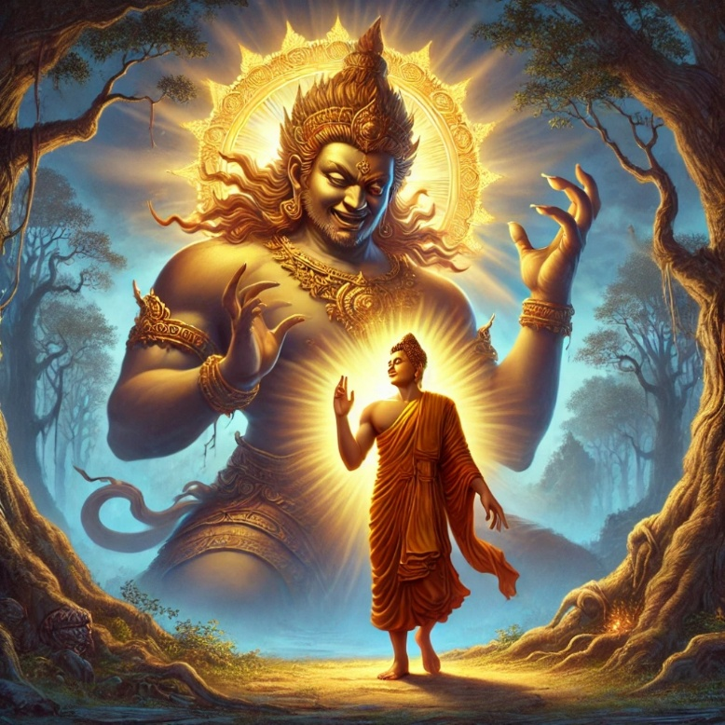

**Taming of Āḷavaka by the Buddha [24]**

Thus, the fearsome Yakkha who once ruled by force became a guardian of righteousness, honouring the Dhamma with unwavering devotion.

His story stands as a testament to the Buddha’s incomparable skill in guiding beings toward awakening—showing that even the most hardened hearts, when touched by wisdom, can turn toward the light of liberation.

Joy of the people of Āḷavī

According to legend, when the people of Āḷavī heard how the Blessed One had transformed the fierce and terrifying Yakka, Āḷavaka, into a gentle and peaceful being, their hearts filled with joy and relief. They realized that, from that moment onward, their land would no longer be darkened by the horrors of human sacrifice. Fear melted away, and the promise of a life free from distress and violence dawned upon them. As they listened to the Buddha’s sublime discourse, wisdom arose in their hearts, and by the time his words had settled, eighty-four thousand among them had entered the path of liberation, attaining the first noble stage—stream-entry. The radiance of the Dhamma had illuminated their land, turning fear into faith, turmoil into peace, and uncertainty into the certainty of the path to Nibbāna. [25]

## Prince Āḷavī’s Progress in the Dhamma

The first episode of the Buddha’s visit to Āḷavī is deeply connected to Prince Āḷavī, who was destined to be sacrificed to a fierce Yakka but was instead saved by the boundless compassion of the Blessed One. The Buddha not only tamed the Yakka, Āḷavaka, but also established him in the Dhamma, transforming a once-terrifying being into a force of peace.

According to tradition, countless thousands in Āḷavī rejoiced and took refuge in the Buddha, and from then on, Buddhism flourished in the land. Prince Āḷavī, also known as Hatthaka of Āḷavaka, was raised in this environment of wisdom and virtue. Unlike many princes whose lives are often marked by indulgence and reckless company, he grew up surrounded by the teachings of the Buddha. As a result, he remained free from the taint of unwholesome deeds and bad associations, his life guided by the light of the Dhamma.

### The Story Behind the Name "Hatthaka of Āḷavaka"

Legend provides a fascinating account of how the prince came to be known as Hatthaka. It is said that when the Buddha tamed the fierce Yakka, the royal guards from King Āḷavī’s palace, unaware of the transformation, arrived at the scene with the infant prince—offering him as a sacrifice. However, the now gentle and subdued Yakka, filled with newfound kindness, took the child into his hands with great care and then placed him in the hands of the Blessed One.

The Supreme Buddha, the embodiment of boundless compassion, held the prince and blessed him. In return, he handed the child back to the royal guards, who then carried him to the palace. The king, overcome with relief and gratitude upon seeing his son safe from a cruel death, joyfully placed him in the arms of the queen, who was still weeping over her beloved child. Since the infant had passed through so many hands—those of the Yakka, the Buddha, the royal guards, the king, and the queen—he was thereafter called "Hatthaka," meaning "one who has passed through many hands.

Prince Hatthaka’s Encounter with the Buddha **[26]**

Years later, as a young man, Hatthaka encountered the Blessed One again. At that time, the Buddha was residing in Āḷavī, seated on a heap of leaves spread upon a cow track in a siṃsapā grove. As Hatthaka wandered for exercise, he noticed the Buddha sitting there, serene and composed. Approaching with deep reverence, he paid homage and respectfully took a seat to one side.

Looking at the Buddha, Hatthaka asked,***"Bhante, did the Blessed One sleep well?"***

The Buddha, ever radiant and at peace, replied, **"*Yes, prince, I slept well. I am one of those in the world who sleep well."***

Puzzled, Hatthaka inquired further, pointing out the harsh conditions of the season*:*

*"Bhante, the winter nights are bitterly cold. The ground, trampled by the hooves of cattle, is rough. The bedding of leaves is thin, the trees nearly bare, and the ochre robes provide little warmth. The wind blows fiercely. And yet, the Blessed One says, ‘Yes, prince, I slept well. I am one of those in the world who sleep well.’ How is this so?"*

The Buddha then posed a question to the prince:

*"Tell me, prince, what do you think? Suppose a householder lives in a well-built home with a peaked roof, plastered inside and out, free from drafts, with bolts fastened and shutters closed. Suppose he has a fine couch spread with rugs, blankets, and covers, with a canopy above, and an oil lamp burning. Suppose four wives serve him in all agreeable ways. Do you think he would sleep well?"*

Hatthaka replied*,* ***"Yes, Bhante. He would surely sleep well."***

The Buddha then asked, *"But tell me, prince, might that householder be troubled by bodily and mental distress born of lust, tormenting him so that he sleeps poorly?"*

*"Yes, Bhante."*

*"However, the Tathāgata has abandoned such lust, uprooted it completely, like a palm stump cut away, so that it can never arise again. That is why I sleep well."*

The Buddha then continued, ***"****What do you think, prince? Might that householder be afflicted by bodily and mental distress born of hatred? By distress born of delusion?"*

Hatthaka acknowledged*, "Yes, Bhante."*

The Buddha explained*, "But the Tathāgata has abandoned hatred and delusion, severed them at the root, like a palm stump destroyed beyond regrowth. That is why I sleep well."*

Then the Blessed One spoke these profound verses:

"The brahmin who has attained Nibbāna,  
cooled, free from attachments,  
untouched by sensual desires—  
having severed all bonds,  
having removed all anguish from the heart—  
sleeps peacefully, his mind at perfect rest."

Upon hearing these words of deep wisdom, Prince Hatthaka of Āḷavī was filled with joy and reverence, his heart uplifted by the truth of the Dhamma.

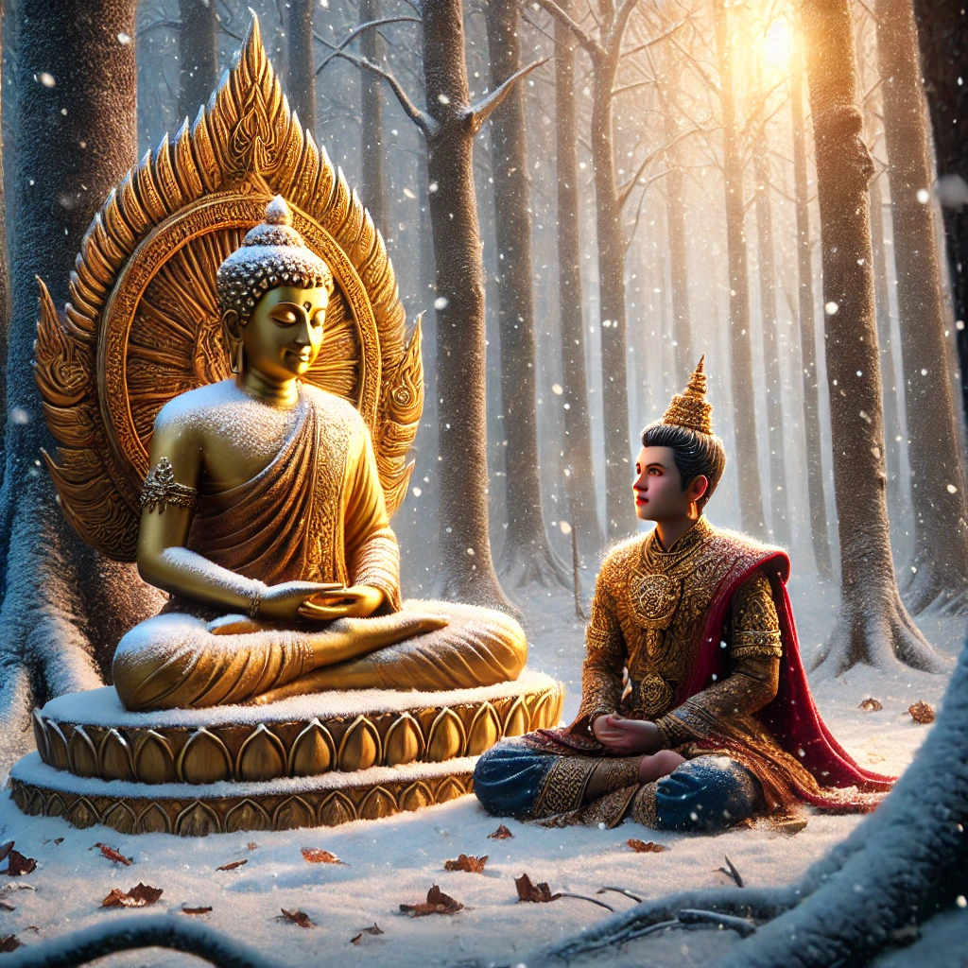

**Prince Hatthaka of Āḷavī listening to the Buddha’s Teachings[27]**

## The Buddha’s Praise for Prince Hatthaka of Āḷavī

Once, while the Blessed One was residing at Āḷavī, near the sacred Aggāḷava Shrine, he turned to the bhikkhus and extolled the virtues of Prince Hatthaka of Āḷavī, saying:

“Bhikkhus, remember Hatthaka of Āḷavī as one who possesses seven extraordinary and admirable qualities.” [28]

What are these seven?

1. **He is endowed with unwavering faith.**
2. **He upholds impeccable virtue.**
3. **He possesses a profound sense of moral shame.**
4. **He has deep moral dread of wrongdoing.**
5. **He is learned in wisdom.**
6. **He is generous and open-handed.**
7. **He is discerning and wise.**

On the following morning, a bhikkhu took his alms bowl and robe and went to the residence of Prince Hatthaka. Seeing him, the prince approached with reverence, paid homage, and sat respectfully to one side. The bhikkhu then said:

*“Friend, the Blessed One has declared that you possess seven extraordinary and admirable qualities.”*

Hearing this, the prince inquired,*“Bhante, I hope no white-robed laypeople were present when the Blessed One spoke these words?”*

The bhikkhu replied, **“***No layperson was present.”*

At this, Prince Hatthaka expressed his relief**: “***That is good, Bhante.”*

After receiving alms from the prince, the bhikkhu returned to the monastery and reported the exchange to the Blessed One. Upon hearing this, the Buddha declared:

*“Good, good, bhikkhu! This clansman has few desires. He does not seek recognition for his inner virtue. Therefore, remember Hatthaka of Āḷavī as one who possesses* ***an eighth extraordinary and admirable quality—fewness of desires****.”*

## The Power of Virtuous Leadership

On another occasion, Prince Hatthaka of Āḷavī, accompanied by five hundred devoted lay followers, approached the Buddha and paid homage. The Blessed One then asked him: [29]

“Hatthaka, your retinue is vast. By what means do you sustain such a following?”

The prince humbly replied:

Bhante, I follow the four principles of harmonious relationships (saṅgaha-vatthu) taught by the Blessed One:

1. If a person is to be sustained by generosity, I offer gifts.
2. If a person is to be sustained by kind and endearing speech, I speak with warmth and affection.
3. If a person is to be sustained by acts of service, I assist them through beneficial conduct.
4. If a person is to be sustained by impartiality, I treat them equitably, sharing in their joys and sorrows.”

He continued, “Bhante, there is wealth in my family, and my followers do not see me as one who is destitute and powerless. Because of this, they listen to my counsel, follow my advice, and do not disregard my guidance.”

Hearing this, the Buddha praised the prince and expounded further:

“Excellent, Hatthaka! This is indeed the way to sustain a great following. In the past, those who upheld large retinues did so by these same four principles. In the future, those who cultivate devoted assemblies will do so by these same four principles. Even now, those who gather and sustain a great following do so by these same four principles.”

Then the Blessed One recited these verses:

### The Four Pillars of Harmonious Relationships

Through generosity, kind speech,  
Beneficial conduct, and impartiality,  
Under diverse worldly conditions,  
As is fitting for each circumstance—  
These noble principles  
Are the linchpin of a moving chariot. [30]

Without these pillars of harmony,  
Even parents would fail to earn  
The love and respect of their children.

Yet, because these principles exist,  
The wise uphold them with reverence.  
Through them, they rise to greatness,  
Adorned with the highest praise.

### Thus, the Blessed One revealed the wisdom of skilful association:

Some are won over by generosity, so give to them. Others are moved by kind words, so speak gently to them. Some require guidance in wholesome conduct, so advise them wisely: “This is beneficial, this is not. Associate with this one, not with that one.” And some need the reassurance of companionship, so share in their joys and sorrows—sit with them, eat with them, and foster a spirit of unity. This, bhikkhus, is how the wise sustain meaningful relationships and inspire others to walk the path of virtue.[31]

The Spiritual Journey of Prince Hatthaka of Āḷavī  
A Model Lay Follower

The path to true happiness, both in this life and in future lives, is illuminated by those who walk steadfastly in the Dhamma. Among such noble beings was Prince Hatthaka of Āḷavī, whom the Buddha himself extolled as an exemplary lay disciple.

The Blessed One once declared:  
“*Bhikkhus, a male lay follower endowed with faith, rightly aspiring, should aspire thus: May I become like Citta the householder and Hatthaka of Āḷavī!” [32]*

**What made Hatthaka so remarkable?** The Buddha revealed that he **was endowed with six noble qualities** that granted him unshakable certainty in the Tathāgata and the realization of the deathless: [33]

1. Unwavering confidence in the Buddha,
2. Unwavering confidence in the Dhamma,
3. Unwavering confidence in the Saṁgha,
4. Noble virtuous behaviour,
5. Noble knowledge, and
6. Noble liberation.

Possessing these virtues, he became a seer of the deathless, one who lived with the realization of Nibbāna in his heart. Such is the great treasure of faith and wisdom—the true wealth that surpasses all worldly riches.

A Favourable Rebirth  
Hatthaka’s devotion bore fruit beyond this transient human life. One night, as the Buddha resided in Jeta’s Grove at Sāvatthī, the young deva Hatthaka appeared before him, radiating a brilliant light that illuminated the entire grove. [34] With deep reverence, he paid homage to the Blessed One and stood to one side.

The Buddha then asked:  
*“Hatthaka, do those teachings that you could recall in the past, when you were a human being, come back to you now?”*

Hatthaka replied joyfully:  
*“Bhante, those teachings that I could recall in the past, when I was a human being, come back to me now; and those teachings that I could not recall in the past, when I was a human being, come back to me now. Just as the Blessed One is now surrounded by the Saṁgha and lay followers, so am I surrounded by young devas, who approach me, eager to hear the Dhamma.”*

He then revealed the noble longing that guided his life:  
“I died, Bhante, insatiable and unquenchable in three things:

1. I died insatiable and unquenchable in seeing the Blessed One.
2. I died insatiable and unquenchable in hearing the good Dhamma.
3. I died insatiable and unquenchable in attending upon the Saṁgha.

I could never get enough of seeing the Blessed One,  
hearing the good Dhamma,  
and attending on the Saṁgha.”[35]

For Hatthaka, the pursuit of the Dhamma was not a burden but a source of boundless joy. With a heart deeply devoted to the truth, he trained in higher virtue and rejoiced in hearing the sublime teachings. Through such steadfast dedication, he attained rebirth in the exalted Aviha realm, a realm reserved for those who have cultivated the path with unwavering diligence.

The Timeless Lesson  
The life of Hatthaka of Āḷavī shines as an inspiration for all who seek true and lasting happiness. It reminds us that spiritual practice is not merely for this fleeting existence but extends across lifetimes, shaping our journey beyond this world. Just as Hatthaka cultivated faith, virtue, and wisdom, we too must earnestly strive to deepen our practice, so that when the time of departure arrives, we may go forth, insatiable in our love for the Dhamma, and destined for ever greater awakening.

May we all take refuge in the Buddha, Dhamma, and Sangha, walking the path with joy and determination, never growing weary of seeing the noble ones, hearing the good Dhamma, and serving the community of the wise!

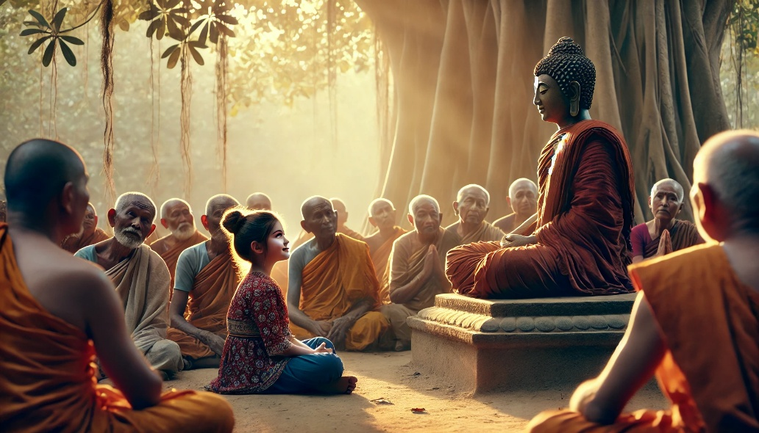

**The young daughter of the village weaver paying attention to the teaching of the Buddha[36]**

The Story of the Weaver’s Daughter

Although the scriptures do not explicitly record this story, the commentaries and tradition recount a remarkable event that took place when the Blessed One was residing at the Aggāḷava Shrine in Āḷavī. [37] It is said that during his stay, a young weaver’s daughter from Āḷavī attained stream-entry after hearing his profound teaching. Since this occurred in Āḷavī, we include it here to highlight the Buddha’s boundless compassion and his appreciation for those who truly understood the Dhamma, regardless of their age or social status.

### The story unfolds as follows:

On one occasion, while staying in Āḷavī, the Buddha delivered a discourse on the contemplation of death (maraṇasati). With great clarity, he urged his listeners to reflect deeply on the fleeting nature of life, saying:

**“Practice mindfulness of death, reminding yourselves:**‘**My life is uncertain; my death is certain.  
My death is inevitable; life will surely end in death.  
Life is utterly uncertain; death is absolutely certain...’**

But those who cultivate this contemplation will have no fear when their final moment arrives.  
Like a steadfast man who, upon spotting a serpent from afar, swiftly lifts it with a stick and casts it away, so too will the wise cast away fear and face death with unshaken serenity.  
Therefore, practice meditation on death.”

Among those gathered to hear these words was a sixteen-year-old girl from a nearby village—the daughter of a humble weaver. Though young in years, her heart was deeply stirred by the Buddha’s teaching. The truth of life’s uncertainty and the inevitability of death resonated within her, awakening a profound understanding.

From that day onward, she never let this contemplation fade. Whether attending to household tasks or assisting her father at the loom, she remained mindful of impermanence. **Weaving threads of fabric by day and weaving threads of wisdom by night**, she lived with the awareness that each breath, each moment, was a step closer to life’s end. Yet, far from despairing, this insight deepened her clarity, her peace, and her devotion to the Dhamma.

Her story reminds us that wisdom is not bound by age or status but is found in the sincerity of one’s practice. Like the weaver’s daughter, may we too take to heart the certainty of death, not with fear, but with the resolve to live wisely, cultivating the path that leads beyond suffering.

### The Weaver’s Daughter’s Second Meeting with the Buddha

When the maiden reached the age of nineteen, the Blessed One once again returned to Āḷavī.

One early morning, as the Teacher surveyed the world with his boundless wisdom and compassion, his gaze fell upon her. Encompassing all beings in his vision, he perceived that this young woman had entered the net of his knowledge. He pondered:

**“What will come of this?”**

And seeing with the eye of wisdom, he discerned:

**“From the day she first heard my discourse, she has earnestly practiced mindfulness of death for three years. Her heart is ripe for deeper understanding. I shall go to Āḷavī and guide her further along the path.”**

Thus, the Buddha, accompanied by a retinue of five hundred bhikkhus, departed from Jetavana and, in due course, arrived at the Aggāḷava monastery in Āḷavī.

When word spread that the Blessed One had arrived, the people of the village rejoiced, and so did the young maiden. Hearing of the Buddha’s presence, her heart leaped with joy. She longed to go at once to see the Teacher, to listen to the Dhamma—**good in the beginning, good in the middle, and good in the end**—a discourse that could illuminate the path to liberation.

Yet, as she prepared to leave, her father, already on his way to the workshop, turned to her and said:

*“Daughter, a garment for a customer is on the loom. I must finish it today. Quickly replenish the shuttle and bring it to me.”*

In that moment, the maiden faced an inner conflict. She thought to herself,

“*I long to hear the Buddha’s discourse, yet my father has given me this task. What should I do? If I fail to**bring him the shuttle, he will surely reprimand me. I will first fulfill my duty to my father, and then, if possible, I will go to hear the Dhamma.”*

With this resolve, she sat down on a stool and carefully replenished the shuttle.

Meanwhile, the people of Āḷavī had prepared a great offering of food for the Buddha and the Sangha. After the meal, they gathered in respectful silence, waiting to hear the Blessed One teach. But the Buddha, knowing the time had not yet come, remained silent. Understanding his intent, the assembled audience—both human and divine—waited in hushed reverence, for when the Teacher is silent, none dare disturb the stillness.

At last, the young woman completed her task. Placing the shuttle in her basket, she set off toward her father’s workshop. Along the way, she passed by the very place where the Buddha was seated, surrounded by the assembly. Something within her compelled her to stop. She lifted her gaze and beheld the Teacher.

At that moment, the Buddha also lifted his head and looked upon her.

There was no need for words—his gaze alone conveyed everything. She understood at once:

**“The Teacher, seated in such an august assembly, looks upon me with meaning. His gaze is an invitation, a silent summons. His sole wish is for me to come into his presence.”**

Without hesitation, she set down her shuttle-basket upon the ground and approached the Blessed One. With deep reverence, she bowed at his feet, then satdown respectfully at one side, awaiting his words.

The entire assembly remained silent; their attention focused on this moment. Then, in the stillness, the Buddha—knower of hearts, guide of the wise—addressed her:

### Buddhas four questions

As the maiden stood before the Blessed One, he addressed her with four profound questions:

**“Maiden, whence have you come?”**  
**“I know not, venerable sir.”**

**“Whither do you go?”**  
**“I know not, venerable sir.”**

**“You know not?”**  
**“I know, venerable sir.”**

**“You know?”**  
**“I know not, venerable sir.”**

Upon hearing this unusual exchange, the assembled crowd murmured in confusion. Some were even offended, whispering among themselves:

*“See how this weaver’s daughter speaks so freely with the Fully Enlightened One! When he asked her, ‘Whence have you come?’ she should have simply answered, ‘From my father’s house.’ And when he asked, ‘Whither do you go?’ she should have said, ‘To the weaver’s workshop.’”*

But the Teacher, ever patient and wise, silenced the assembly and turned again to the maiden.

**“Maiden, when I asked you, ‘Whence have you come?’ why did you reply, ‘I know not’?”**

With calm and clarity, she answered:

**“Venerable sir, you already know that I have come from my father’s house. But I understood your question to have a deeper meaning: ‘Whence have you come into this existence?’ And as for that, I do not know.”**

The Buddha smiled and said, **“Well said, O maiden! You have answered rightly.”**

Then, he asked his second question again:

**“When I asked, ‘Whither do you go?’ why did you say, ‘I know not’?”**

The maiden replied:

**“Venerable sir, you know well that I am going to the weaver’s workshop, carrying my shuttle-basket. But I understood your question to mean, ‘When you leave this life, where will you be reborn?’ And that, venerable sir, I do not know.”**

Again, the Buddha praised her: **“Well said! You have answered correctly.”**

Then he asked:

**“When I asked, ‘Know you not?’ why did you say, ‘I know’?”**

She responded with unwavering certainty:

**“Venerable sir, this much I do know—I shall surely die one day. And therefore, I answered, ‘I know.’”**

The Buddha commended her wisdom: **“Indeed, you have spoken well.”**

Lastly, he asked:

**“When I asked, ‘Know you?’ why did you say, ‘I know not’?”**

The maiden replied:

**“Venerable sir, I know for certain that death will come. But at what time it will arrive—whether by day or by night, in the morning or evening—that I do not know. And therefore, I answered thus.”**

At this, the Buddha declared: **“You have truly answered well.”**

Then, turning to the assembly, he addressed them with great compassion:

**“***You who were disturbed by her words failed to grasp their meaning. The world is blind, and those who lack wisdom do not see the truth. But those whose inner eye of wisdom is open; they alone perceive reality as it is.”*

And he uttered the following verse: [38]

**"This world is blind; only a few here truly see.**  
**As few attain heaven as the birds that escape from the hunter’s net."***:*

*( Andhabhūto ayaṁ loko, tanukettha vipassati,  
Sakunto jālamutto va, appo saggāya gacchati.)*

As the Buddha concluded his discourse, the young maiden attained the fruit of Stream-entry. Many others, too, were uplifted by his words and gained deep insight into the Dhamma.

### The Maiden’s Final Moment and the Father’s Awakening

With the Teacher’s words still resonating in her heart, the maiden picked up her shuttle-basket and made her way to her father’s workshop. Unaware that he had dozed off at the loom, she approached and presented the basket. Just then, as the basket accidentally struck the tip of the loom, it fell to the ground with a sudden clatter. Startled from his sleep, her father instinctively reached out and pulled the loom. But in that fateful moment, the tip of the loom swung violently and struck his daughter in the chest.

Without a cry, without hesitation, her life came to an end.

At that very instant, she was reborn in the celestial realm of Tusita,

her heart’s purity and wisdom bearing fruit in the heavens.

Her father, however, saw only her lifeless body before him. Crimson spots of blood marked her form, once full of vitality, now utterly still. A wave of sorrow surged through him, crashing like a great tide. Overcome with grief, he wailed aloud:

**“*My daughter, my child! Who will now ease this unbearable sorrow?”***

Torn by his anguish, he sought out the one refuge that remained—the Buddha, the great comforter of those in suffering. Rushing to the Blessed One, he fell at his feet and cried out:

*“Venerable Sir, my daughter is gone! My heart is heavy with sorrow. Please, I beg you, extinguish my grief!”*

The Teacher, ever compassionate, looked upon him with gentle understanding and spoke words of deep truth:

**“*Grieve not, disciple, for in the endless cycle of birth and death, you have wept for lost loved ones more than all the water contained in the four great oceans.”***

With these words, the Blessed One revealed to him the boundless nature of saṃsāra, the unceasing wanderings through birth and death, joy and sorrow, union and separation—without discernible beginning.

As the father listened, the storm of his grief began to subside. The truth of the Dhamma settled within him, like a cool rain quenching parched earth. The sorrow that had once consumed him loosened its grip, and in its place arose the desire for true liberation.

With a heart awakened to the fleeting nature of all things, he bowed before the Teacher and humbly requested ordination. The Blessed One granted his request, and in due time, having diligently practiced the Noble Path, he attained Arahantship—the highest liberation, beyond sorrow, beyond birth and death.

Thus, from the sorrow of loss arose the light of wisdom, and what had seemed an end became the beginning of final freedom.

## The Significance of Buddha’s Visit to Āḷavī

* The Buddha’s choice to travel alone underscores his fearlessness and commitment to spreading the Dhamma, even in places where spiritual forces, such as the Yakkha Āḷavaka, posed challenges.
* His teachings in Āḷavī likely left a lasting impact on the region, fostering new disciples and followers.
* The presence of Prince Hatta Āḷavaka in different stages of life illustrates the long-term influence of the Buddha’s teachings, showing how Dhamma guides people through different phases of life, from childhood to adulthood.
* The young daughter of the village weaver had the opportunity to meet the Blessed One, realized the truth was established in the first stage to the noble path.

This journey, though often overlooked, stands as a powerful testament to the Buddha’s boundless compassion, his ability to tame even the fiercest of beings, and his unwavering dedication to liberating all those trapped in the cycle of suffering.

The profound lesson we learn here is that the Dhamma is accessible to all—whether a noble prince or a humble, unlettered weaver’s daughter. The Buddha’s teachings transcend social status, offering wisdom perfectly suited to the needs and capacities of each individual. This truth should inspire us to walk the path with unwavering determination, knowing that liberation is not reserved for a select few, but is within reach of anyone who earnestly seeks it. Let us take heart from these great examples and resolve to free ourselves from suffering.

## The Seventeenth Rainy Season at Veluvana Monastery- Age 51

After spending his sixteenth vassa in Āḷavī, the Blessed One travelled to Rājagaha and resided at Veluvana Monastery. As mentioned in Section 15-1, he had also spent his second to fourth vassa in Rājagaha. While the scriptures do not explicitly state the location of his seventeenth vassa, commentaries and other sources confirm that he spent this rainy season in the city of Rājagaha.

### Evidence from other sources

1) The seventeenth was surely near Rājagaha (perhaps in Bamboo Wood)[39]

(**sattarasamaṁ Rājagahe yeva)**

2) The unsurpassed Great Seer, whose fame had spread throughout the three realms, in the seventeenth Rains Retreat, dwelt near the excellent Rājagaha, which delighted the eyes with its ramparts, gateways, houses, archways, and so forth. [40]

(Bhuvana-ttayasmiṁ patthaṭa-yaso anadhivaro Mahesī, dasasattamamhi Vassamhi, pākāra-gopura-niketana-toraṇa-ādi netta-abhirāma-vara-Rājagahe vāsaṁ akā.)

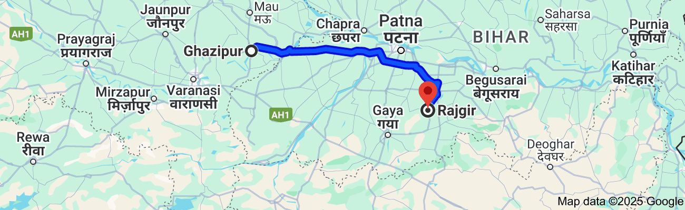3) After taming and converting the Yakka Ãlvaka while observing the sixteenth vassa ta Ãlavi city, the Buddha exhorted and taught those beings who were worthy of his teaching. When the vassa came to an end, he journeyed from the city of Ãlavi and reached the city of Rājagaha eventually and he stayed at the Veleuvana monastery of the city to keep the seventeenth vassa.[41]

**Road map: Distance from Ghazipur, UP (formerly Ãlavi) to Rajgir, Bihar 216 km [42]**

Although neither the scriptures nor the tradition provides a detailed account of the Buddha’s journey from Āḷavī to Rājagaha, we can infer that he travelled on foot across a considerable distance—approximately 14.1 yojanas (assuming 1 yojana equals 15 km). Along the way, many fortunate individuals may have had the rare opportunity to encounter the Buddha, listen to his profound teachings, and benefit from his wisdom and boundless compassion. The scriptures and tradition consistently depict the Blessed One as making special efforts to reach those who were receptive to the Dhamma, guiding them toward greater confidence in the teachings and alleviating their suffering.

Upon his arrival at the serene Veluvana Monastery, the Saṅgha—who had been eagerly awaiting their teacher’s return, much like hungry children longing for their mother’s nourishment—would have been overjoyed to hear the good Dhamma once more. King Bimbisāra, a stream-enterer, along with his royal entourage and many devoted followers from Magadha, must have welcomed him with great reverence and delight.

## Events Before the Commencement of Vassa

According to the *Dhammapada Aṭṭhakathā* and tradition [43], the Buddha delivered the *Vijaya Sutta* (Snp 1.11), also known as the *Kāyavicchandanika Sutta*—the discourse on removing desire for the body—during this time. This sutta illustrates the impermanent and impure nature of the body, emphasizing that beauty is merely skin deep. It was specifically preached to help a monk, a disciple of the Buddha, who was struggling with desire for a renowned courtesan in Rājagaha.

The background story centres on Sirimā and Uttarā. Uttarā, the daughter of the wealthy merchant Puṇṇa in Rājagaha, was a devoted follower of the Buddha. When a rich merchant, Sumana, sought her hand for his son, Puṇṇa hesitated since Sumana’s family were non-believers. After much negotiation, the marriage took place at the onset of the rainy season.

Once in her new home, Uttarā was deprived of opportunities to see monks, offer alms, or listen to the Dhamma. After enduring this for two and a half months, she sent a heartfelt message to her parents:

*"Why have you imprisoned me like this? It would have been better to sell me as a slave than to marry me into a family of unbelievers. I have not been able to perform a single act of merit."*

## The Power of Loving-Kindness and Forgiveness

Upon receiving his daughter's anguished message, Puṇṇa was deeply troubled. Out of compassion, he devised a plan: he sent her fifteen thousand gold coins, instructing her to hire the renowned courtesan, Sirimā, to take her place as a wife for a fortnight. This arrangement freed Uttarā to engage in meritorious deeds, offering alms and listening to the Buddha’s teachings. Thus, blinded by sensuality, her husband readily agreed—unaware of the fleeting nature of such pleasures.

Each day, Uttarā joyfully served the Buddha and his monks. As the rains retreat drew to a close, she busied herself in the kitchen, eagerly preparing for the great alms offering. Seeing her toil, her husband scoffed at what he considered foolish devotion. When Sirimā noticed his smile, jealousy flared within her. No longer feeling like the mistress of the house, she seized a ladle of boiling oil and, in a fit of rage, rushed toward Uttarā to harm her.

Yet, filled with boundless gratitude, Uttarā bore no anger. She reflected:

*"Through Sirimā’s presence, I have been blessed with this rare opportunity to serve the Buddha and hear the Dhamma. If I harbor even a trace of ill will, may this oil burn me. But if my heart is pure, may it cause me no harm."*

With this thought, she radiated loving-kindness toward Sirimā. When the boiling oil touched her skin, it cooled as if it were pure water.

Overcome with fury, Sirimā attempted again, but Uttarā’s maids intervened, restraining and beating her. With unwavering compassion, Uttarā shielded her attacker and gently asked, *“Why did you do this?”*

She then cleansed Sirimā’s wounds and anointed her with fragrant perfume.

Realizing the enormity of her wrongdoing, Sirimā was struck with remorse. She thought:

*"I have committed a terrible act, yet Uttarā harboured no anger and even protected me. If I do not seek her forgiveness, may my head split into seven pieces."*

Overcome with humility, she prostrated at Uttarā’s feet.

Uttarā, however, replied,

*“If the father who brought me into this cycle of suffering forgives you, so will I.”*

When Sirimā offered to seek Puṇṇa’s pardon, Uttarā gently corrected her: *“*

*Puṇṇa is my father by birth, but the Buddha is the one who leads me out of suffering. If he forgives you, so will I.”*

With newfound sincerity, Sirimā vowed to seek refuge in the Buddha. She resolved to approach him the next day, bringing offerings and humbly asking for his forgiveness.

## The Triumph of Loving-Kindness

Humbled by her wrongdoing, Sirimā gladly accepted Uttarā’s advice. She returned home and instructed her many attendants to prepare a grand offering of food. The next day, she brought the offerings to Uttarā’s house but, still ashamed, dared not serve the monks herself. Uttarā, embodying boundless kindness, took charge and ensured everything was done with care.

When the meal was over, Sirimā knelt at the Buddha’s feet and sought his forgiveness. The Enlightened One asked what she had done. As she recounted the incident, he turned to Uttarā and inquired about her thoughts when Sirimā approached her with the boiling oil.

*"I suffused her with loving-kindness,"* Uttarā replied. *"I reflected that my friend Sirimā had granted me a great opportunity to perform meritorious deeds."*

*"Excellent, Uttarā, excellent!"* the Blessed One declared. *"That is the true way to overcome anger."* He then uttered this profound verse:

*"Overcome anger by non-anger,*

*conquer evil by goodness,*  
*Conquer the niggardly with a gift,*  
*And the liar with truth."*  [44]

With great compassion, the Buddha expounded the Dhamma, revealing the Four Noble Truths. Inspired by his teachings, Uttarā attained the fruit of once-returning. Her husband, once indifferent to the Dhamma, along with his parents all realized the fruit of stream-entry. Sirimā, too, reached the path of stream-entry, her heart transformed.

From that day on, Sirimā dedicated herself to supporting the Saṅgha. She arranged for eight monks to receive alms at her home daily, issuing invitation vouchers to ensure the offerings were shared fairly among the Order. Her past misdeed became the turning point for a life of generosity and devotion, illustrating the boundless power of loving-kindness and the transformative nature of the Dhamma.

## The Lesson of Sirimā: The Fleeting Nature of Beauty

One day, a monk who had dined at Sirimā’s house returned to his monastery and enthusiastically described the lavish meals she provided. He also praised her extraordinary beauty, claiming that her charm surpassed even the excellence of her offerings. As he spoke, another monk, who had never seen Sirimā, became infatuated with her, overwhelmed by desire. Determined to see her, he secured a meal invitation for the next day.

However, on that very day, Sirimā had fallen ill. She lay in bed, weak and without her usual finery. When the monks arrived, she struggled to stand, trembling as two maids supported her. Even in this frail state, the love-struck monk found her beauty captivating and imagined how much more enchanting she must be when adorned with jewels. Overcome by passion, he lost his appetite, returned to the monastery, and lay in anguish, unable to eat for days.

The Buddha, seeing his plight, resolved to teach a profound lesson. He instructed King Bimbisāra to place Sirimā’s body in the cemetery for three days after her passing. Then, a royal decree was issued: all adults in Rājagaha must come to see her remains, or face a fine. By the third day, her once-admired body had swollen, decayed, and was crawling with worms, a stark contrast to its former allure.

Hearing that the Buddha was going to see Sirimā, the love-stricken monk, weak from fasting, sprang to his feet at the mere mention of her name. He emptied his bowl, washed it, and rushed to join the crowd. When they arrived, the Buddha turned to King Bimbisāra and asked, *“Who is this, great king?”*

*"This was Sirimā, the beloved courtesan,"* [45]the king replied.

Then, the Buddha proclaimed: *"Let it be announced that whoever offers a thousand gold coins may have Sirimā."* But no one came forward. Even when the price was lowered—first to a single coin, then to nothing—not a single person wanted her now.

Then the Buddha spoke: *“Monks, here lies a woman once cherished by many, for whom men paid a thousand gold coins for a single night. Yet now, none will have her, not even for free. Behold the true nature of the body—perishable, fragile, and made appealing only through adornments. It is a house of decay, a burden of suffering. Only fools become attached to such an impermanent thing.”*

He then recited this verse:

*"See this skin-bag all adorned;*  
*It is just a mass of wounds.*  
*Diseased, an object of desires,*  
*It has nothing stable or lasting."* [46]

Hearing this, the love-struck monk saw through his delusion. Deeply contemplating the nature of the body, he developed insight, broke free from craving, and soon attained arahantship.

Thus, the Blessed One, with unparalleled wisdom, transformed desire into wisdom and infatuation into liberation, revealing the truth of impermanence to all who were ready to see.



**This seemingly beautiful body is, in truth, nothing more than a mere bundle of bones. When we deeply realize this reality, the illusion of sensual desire—binding us to the endless cycle of samsara—begins to dissolve. With wisdom and insight, we can break free from these attachments and walk the noble path to liberation, untouched by the fleeting illusions of the world. [47]**

### Victory Over Delusion

This body, though appearing beautiful, is merely a fragile vessel—held together by bones and sinews, filled with impurities, and constantly oozing from its many openings. Yet, blinded by ignorance, one clings to it, mistaking it for something worthy of attachment.

But when wisdom arises, the truth is seen: this body is impermanent, destined to decay, to be discarded and devoured. Knowing this, the wise abandon desire, breaking free from the chains of delusion. With insight, they transcend suffering and attain the deathless—Nibbāna, the supreme peace.[48]

With that inspiring Dhamma note we will conclude this section. The next section (Section: 16-3) will focus on where the Blessed One spent his eighteenth vassa.

### End Notes: Section: 16-2

1. AI generated image
2. See Chapter 33 : The Great Chronicles of the Buddhas by Venerable Mingun Sayadaw.
3. Source 1: Madhuratthavilāsinī (Buddhavaṁsatthakathā) of Bhadantâcariya Buddhadatta Mahathera: Translated by I. B. Honer, 1946.
4. Source 2: Jinacaritaṁ, The Life of the Victorious Buddha, translated by Bhikkhu Anandajoti.
5. See SN: Note: 593: it says … One day King Āḷavaka of Āḷavı̄, while on a hunt, was captured by the ferocious yakkha Āḷavaka, who threatened to eat him. The king could obtain release only by promising the demon that he would provide him daily with a human victim. First the king sent the criminals from the prison, but when there were no more prisoners, he required every family to provide a child. All the families with children eventually fled to other lands and it became incumbent on the king to offer his own son, the Āḷavaka

   prince. The Buddha, aware of the impending sacrifice, went to the yakkha’s haunt on the day before the

   offering was to take place in order to convert the demon from his evil ways.
6. Source3: Chapter 33: The Great Chronicles of Buddhas by Venerable Mingun Sayadaw.
7. Source: Dictionary of Pāli Proper Names by G.P. Malalasekera.
8. Ibid.* See also: Chapter 33: The Great Chronicles of Buddhas by Venerable Mingun Sayadaw.
9. AN1:251. The four means of attracting and sustaining others (*saṅgahavatthu*) are at AN4:32.
10. See: SN: Note: 331: Thı̄ 58. Thı̄-a 60 confirms the identity of the two bhikkhunı̄s, explaining that Selā was called Āḷavikā because she was the daughter of the king of Āḷavaka. She heard the Buddha preach and became a lay follower. Later she took ordination as a nun and attained arahantship.
11. In SN8: (Vangisasamutta) many suttas mention that Venerable Vaṅgīsa was dwelling at Āḷavī at the Aggāḷava Shrine together with his preceptor, the Venerable Nigrodhakappa.
12. Source: Dictionary of Pāli Proper Names by G.P. Malalasekera.
13. Source: Wikipedia.
14. Source: Tathāgatassa Vassā: The Realised One’s Rains Retreats by Bhikkhu Ãnandajoti
15. Source: https://proneta.in/ghazipur_assembly_constituency_uttar_pradesh-375
16. Source: Google.
17. SN 10:12 * In Snp:1.10 also gives a similar account of the Buddha’s encounter with the Yakka Āḷavaka.
18. SN: 10:12
19. For more details see: SN: Note: 597.
20. For more details see: SN: Note: 598.
21. For more details see: SN: Notes: 599 & 600
22. For more details see: SN: Note: 602
23. SN10:12 * Commentary says: Just as the yakkha finished speaking this verse the king’s men arrived bringing the prince as a sacrificial offering. They handed the infant to the yakkha, who presented him to the Buddha. The Master recited some verses of blessing over the boy and

    returned him to the king’s men. When the prince reached maturity, he was known as Hatthaka Āḷavaka, because he had been passed around from one person’s hands (*hattha*) to another’s. He attained the stage of nonreturner and was one of the Buddha’s foremost lay disciples., see: SN: Note: 604.
24. AI generated Image
25. For details see: Chapter 33: The Great Chronicles of Buddhas by Venerable Mingun Sayadaw.
26. AN3:35
27. AI generated Image
28. AN8: 23
29. AN8:24
30. AN4:32
31. The four means of attracting and sustaining others (*saṅgahavatthu*) see AN: 4:32.
32. See:(AN2:132, AN4:176, SN17:23
33. AN6:120
34. He was born in *Aviha* Brahama world, 0ne of the five pure abodes (*suddhāvāsa*) into which only non-returners are reborn. See: AN: Notes: 591.
35. AN3:127
36. AI generated image.
37. Source: 13.7 The Story about the Weaver’s Daughter Pesakāradhītāvatthu : A Revised Translationof the Dhammapada Aṭṭhakathā together with a New Translation of All the Verse Texts

    E W Burlingame, Ānandajoti Bhikkhu: https://ancient-buddhist-texts.net/English-Texts/Dhamma-Verses-Comm/index.htm
38. Dhp: 174
39. Source 1: Madhuratthavilāsinī (Buddhavaṁsatthakathā) of Bhadantâcariya Buddhadatta Mahathera: Translated by I. B. Honer, 1946.
40. Source 2: Jinacaritaṁ, The Life of the Victorious Buddha, translated by Bhikkhu Anandajoti.
41. Source 3: Chapter 24: The Great Chronicles of the Buddhas by Venerable Mingun Sayadaw.
42. Map source: Google.
43. Source: A Revised Translationof the Dhammapada Aṭṭhakathā together with a New Translation of All the Verse Texts E W Burlingame, Ānandajoti Bhikkhu,
44. Dhp: 223
45. According to tradition Sirima was the daughter of Salavati, the first courtesan of Rajagaha appointed by the King, her son was Jivaka who became the famous physician during the time of the Buddha, he served King Bimbisara as a the royal physician and lovingly looked after the Buddha and the Sangha.
46. Dhp:147
47. AI generated image.
48. Summary of Vijaya sutta: Snp:1.111